**2**

**Grammar of graphics and visual components**

**Lesson Objectives**

**Show Slide 1**

By the end of this lesson, you will be able to:

Understand the grammar of graphics in greater details and be able to use:

* 1. Layers
  2. Scales
  3. Coordinates

Use faceting to make multiplots and divide the data into subplots.

Use colors effectively in plots to visualize and understand the data better and be able to use themes to customize the appearance of graphs.

Group data to create statistical summaries like means, medians and other variables.

**Lesson time: 2 hrs**

**Logistics**

Start with summarizing the parts that were learnt in the previous lessons. Remind them about

what the terms geometric objects, grammar of graphics etc. means, and the basic plots we

created in the first lesson. Mention that we will be going into greater details on some of the

aspects touched upon in the previous lesson and introduce some more new features.

**Topic A: More on Grammar of graphics**

**Time: 50 mins**

**Show** Slide 2

Grammar of graphics is the language used to describe various components of a graphic which represents the data in a visualization. In this topic, we learn more about this and then use it to make plots. We encountered some of the terms used in Grammar of graphics in the previous lessons.

**Discussion**

What are some of the grammar of graphics we learnt and used in the previous class?

**Answer**

Rebinning, theme. Rebinning and different themes make a visual easier to understand. Rebinning makes a histogram smoother and we are able to decipher the shape better.

We shall now breakdown the grammar of graphics and understand the terms in greater detail. For the exercises and datasets used in Lesson 2, please refer to the code.

**Show** Slide XX

**Subtopic: Layers**

Every plot in ggplot2 is built up as a layer. Layers are made of geometric objects (geoms), their statistical transformations(stats), and thematic aspects. Hence, each plot can be thought of as a separate variable in itself. Aesthetic mappings, defined with aes (), describe how variables are mapped to visual properties or **aesthetics**.

Let’s look at an example. Let’s use the dataset “gapminder”. You can see the variables

available in the snippet below. It has different variables for different countries, for example,

“GDP per Capita”, “Electricity consumption per capita”, and so on.

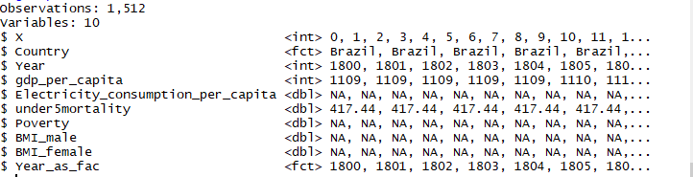

Let’s build a histogram for Electricity consumption per capita. We are not analyzing this histogram so don’t worry about the features.

* The first layer is defining the “aesthetics” or the variables we want to look at - aes

p1 <- ggplot(df,aes(x=Electricity_consumption_per_capita))

* The second layer is defining the geometric object:

p2 <- p1+geom_histogram ()

* In this layer we rebin the histogram:

p3 <- p1+geom_histogram(bins=15)

* Plot the histogram:

p3

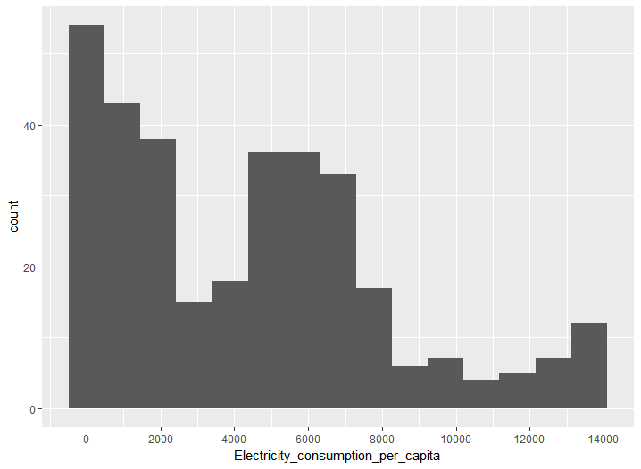

**Exercise**: Using more Layers to customize a histogram

**Aim**: To use layers to customize a histogram

**Steps for completion**:

Plot the two histograms above

Change the x-axis title - Add another layer to change the x-axis title (remove the “_” in the variable name) and save it in a plot - p4.

Try plotting them individually as “p1”, “p2”, “p3”, “p4” on the command line.

**Outcome:**

Four plots.

Final plot should look like this:

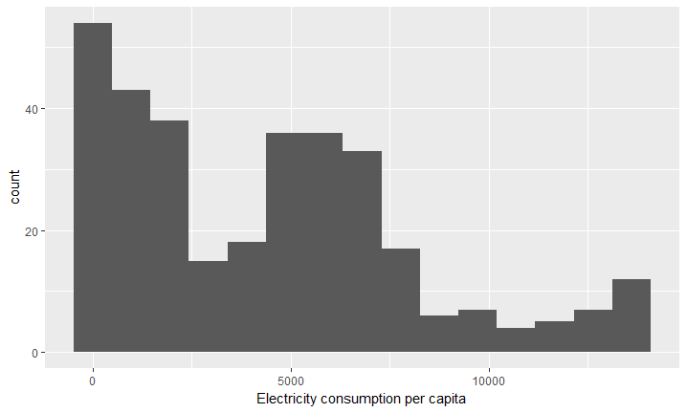

**Discussion:** Why can’t we display “p1”?

**Answer:** Because it is just the command which loads the data and we haven’t defined a geometric object yet, which we do when we define “p2”.

The takeaway from this exercise is that all the three plots, p2, p3, p4 are variables and can be displayed independent of each other. This is what makes layers very powerful, as the individual layers are also saved, and one can keep track of the changes and go back to edit one of the layers if needed. We shall continue to use layers in our coding exercises which follow.

Show Slide 9

**Subtopic: Scales**

Scales map values in the data space to values in an aesthetic space, whether its color, shape or size. Scales are used to change legend or axes, providing an inverse mapping and enable us to understand the data from the graphic itself. In the previous example, when we plotted the histogram, what ggplot actually did was to apply a default scale to describe the x and y-axes. But we can modify that.

To modify scales, the following commands are used:

Continuous variables: **scale_x_continuous** (x-axis), **scale_y_continuous**(y-axis)

Discrete variables: **scale_x_discrete**(x-axis); **scale_y_discrete**(y-axis).

Some of the common things we may like to change are:

* **name:** the first argument gives the axis or legend title
* **limits:** the minimum and maximum of the scale
* **breaks:** the points along the scale where labels should appear
* **labels:** the labels that appear at each break

Let’s use these commands.

Show

Slide 10

Exercise: Using scales for analyzing a dataset

Aim: To explore some of the options available in “scale_x_continuous” and “scale_x_discrete”.

Steps for completion:

* 1. Use the same dataset as before and plot the “gdp_per_capita” as a histogram
  2. Plot p1.

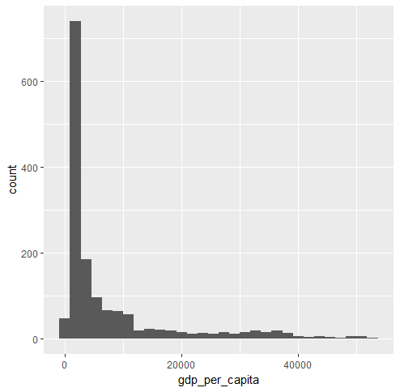

* 1. Can you tell where the maximum occurs? No, because its too approximate. We need a finer labelling.
  2. Study and view the options in scale_x_continuous (Note: Use the command “?scale_x_continuous” on the command line, to see the options)
  3. Add the layer: scale_x_continuous (breaks=seq (0,40000,4000)) (See Code). This command defines a range between 0, 40000, with breaks of 4000.
  4. Now one can identify the maximum better. What is the maximum GDP per capita? What type of histogram is this?

Go to https://goo.gl/RheL2G to access the code.

Outcome:

Code, Histogram, and Answer to Q6: Maximum “GDP per Capita” is about 2000. It’s a right

skewed histogram

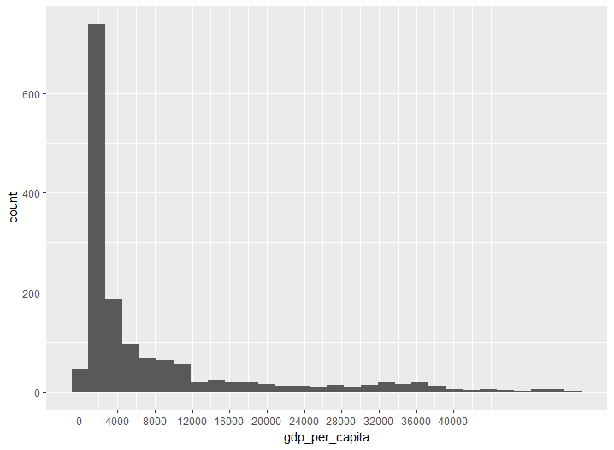

**Instructor Note:** See the documentation of the scales package for more details.

Highlight the importance of scales, and why “breaks” is important as brought up in Q3.

**URL: <https://cran.r-project.org/web/packages/scales/scales.pdf>**

Show Slide 12-13

**Subtopic: Coordinates**

* Cartesian- **coord_cartesian ():** By default, ggplot uses a cartesian coordinate system but sometimes one might want to use polar coordinates, which is another way to look at fractions. So, one use could be to transform a bar chart into a pie chart.
* Polar- **coord_polar ():** In ggplot2, the cartesian coordinates x, y become polar coordinates theta, and r. You can specify which coordinate is theta and which r.

Let’s do an exercise to understand polar coordinates.

**Exercise:** Understanding Polar Coordinates

**Aim:** To generate some numbers and plot them in cartesian and polar coordinates

**Steps for completion:**

1. Generate angles between 0-360 in intervals of 15.

t <- seq(0, 360, by=15)

1. Define another variable the radius r.

r <- 2

1. Use qplot to plot the vectors in cartesian coordinates (Plot1). What do you see? Write your answer in the code in comments.
2. qplot(r,t)

Your first plot should look like Plot 1.

1. Use qplot to plot the vectors in polar coordinates. What do you see? Write your answer.

qplot(r,t)+coord_polar(theta="y")

1. Use “scales” to change the labelling to look like Plot 3. Here we define the range from 0 to 360 with breaks of 30.

qplot(r,t)+coord_polar(theta="y")+scale_y_continuous(breaks=seq(0,360,30))

Go to https://goo.gl/RheL2G to access the code.

**Outcome:**

1. Plots 1,2 and Final Plot
2. Answers in comments in the code. Plot2

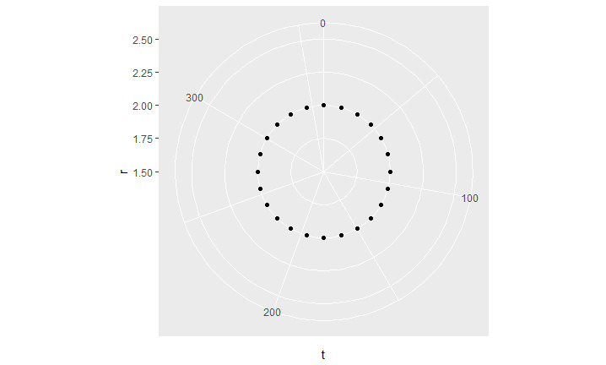 Plot 1

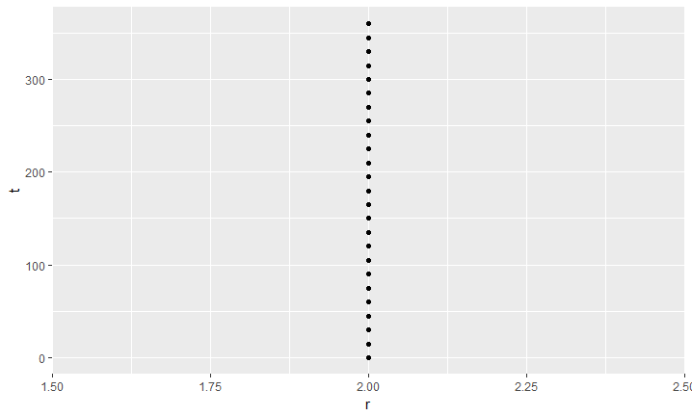

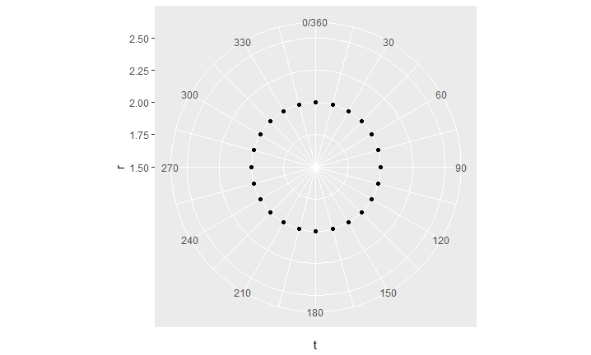Final Plot:

**Discussion:**

Which plot is more informative? Is it the one which is plotted in the cartesian co-ordinate system or the one plotted in the polar co-ordinate system?

Answer:

As one can see angles are much better viewed in polar coordinates and the distance of the points from the centre show us that the radius is a constant for this data. It can be used to also depict fractions, which we shall work on later. The center corresponds to 1.5, and the circles represent the different radii, 1.72, 2.0 and so on.

Changing the formatting of the labels: Various label formats are available and one can change the label formats as well. The following label formats are available:

* scales::comma_format () adds commas to make it easier to read large numbers.
* scales::unit_format(unit, scale) adds a unit suffix, optionally scaling.
* scales::dollar_format(prefix, suffix) displays currency values, rounding to two decimal places and adding a prefix or suffix.
* scales::wrap_format() wraps long labels into multiple lines.

We shall combine all the above commands to make a single plot

**Activity A:**

**Scenario:**

Sometimes one needs to customize a plot and change scales and coordinate types. Say, you have profits

in billions or trillions of dollars, you would want to represent a big number as 1M, or 2M and so on. Or,

you might want to view percentages of profits per month as a pie-chart. In that case you would need to

change your cartesian to polar co-ordinates.

**Aim:**

To use Grammar of graphics to create the given visualization.

Steps for completion:

1. Use the commands we just explored, to create the scatter plot shown below.
2. For this activity, you will use the “gapminder” data set.
3. You can use the help command to explore the options.
4. For changing scales, you have to use one of the label formats above.

(Use labels=scales::unit_format ("K", 1e-3)) for the labelling

Go to https://goo.gl/RheL2G to access the code.

Outcome: A scatter plot which matches the plot below:

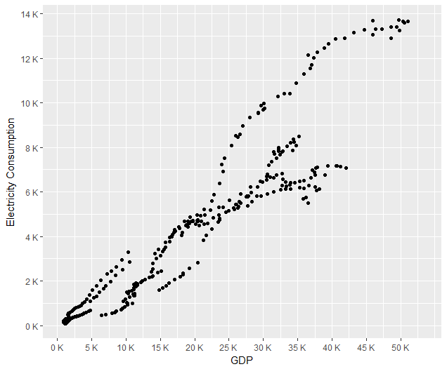

**Instructor Note:**

This is an independent activity and students should try to figure out all the commands needed to produce the above plot and combine the different information they have learnt so far.

**Topic B: Facets**

**Time: 40 mins**

In data visualization, we sometimes need to compare different groups, and look at data alongside each other for the different groups. One way of do this is to create a subplot for each group. These kinds of plots are known as Trellis displays. In ggplot2, they’re called facets. Facets divide the data by some discrete or categorical variable and displays the same type of a graph for each data subset.

Let’s look at “Electricity consumption vs GDP” for different countries, which we just did in the previous activity.

Discussion: What kind of correlation did you see in that plot?

Answer: The Electricity consumption is higher as the GDP grows.

Discussion: But we don’t know which Country has the highest GDP or Electricity consumption. Let’s split the data now.

**Exercise:** Using facets to split data

**Aim:**

To plot subsets of the data as separate subplots

**Steps for completion:**

1. Use dataset “gapminder.csv”
2. Make a scatter plot of Electricity_consumption_per_capita vs GDP_per_capita.

p <- ggplot (df, aes (x=gdp_per_capita, y=Electricity_consumption_per_capita)) +

geom_point ()

1. Use facet_grid () and specify the variables on which to split. We have to plot Electricity Consumption vs GDP for each country separately. So, our split variable is “Country”.

p + facet_grid(Country ~ .)

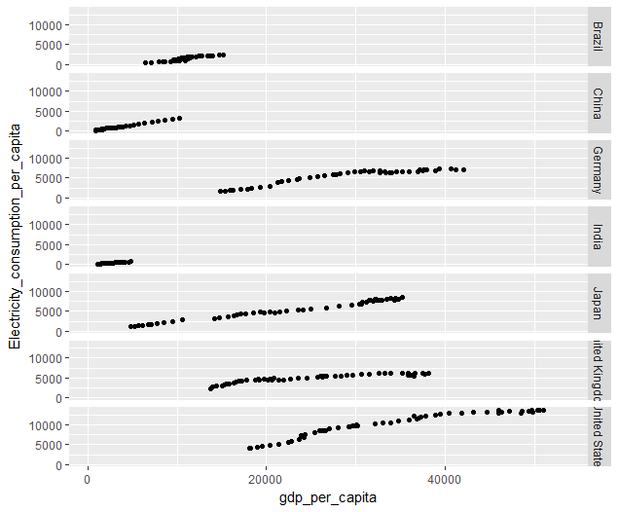

1. One can also arrange the panels vertically.

p + facet_grid (. ~ Country)

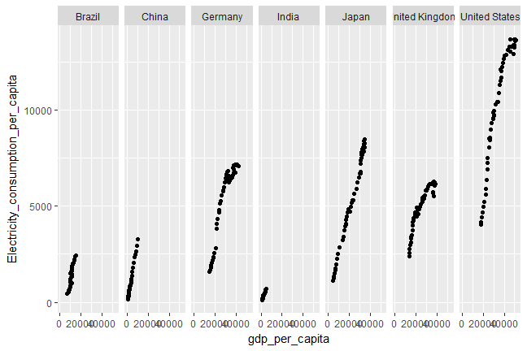

Go to https://goo.gl/RheL2G to access the code.

**Discussion:** Another similar command which can be used is facet_wrap (). With facet_wrap (), the subplots are laid out horizontally and wrap around, like words on a page. The plot would look like this with facet_wrap ()

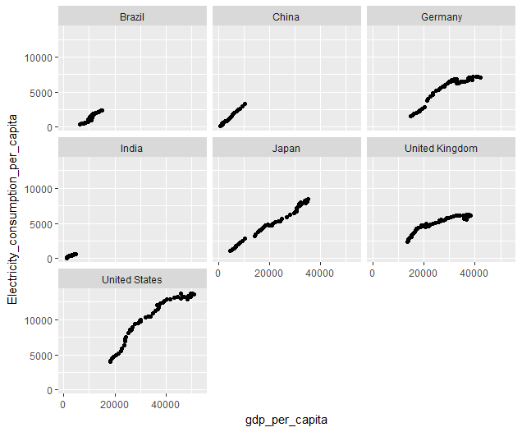

Discussion:

What does one notice about the trend?

**Answer:** The Electricity consumption is higher as the GDP grows for all countries, but now we can see that the electricity consumption is highest for United States. We also see that the growth is different for different countries and one can look at more details if needed.

**Activity B:** Using faceting to understand data

**Scenario:** You want to look at the distribution of loan amount for different credit grades.

**Aim:**

To plot the loan amount for different credit grades using faceting.

**Steps for Completion:**

1. Use the loan data and plot a histogram (use fill color = “cadetblue4” and bins=10)
2. Use facet_wrap to plot it for the different credit grades.

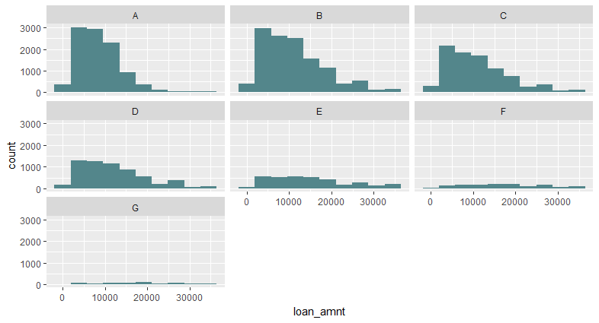

1. Now, you need to change the default options for facet_wrap to produce the plot below and then you can answer the questions. Use “?facet_wrap” on the command line to look at the options to change.

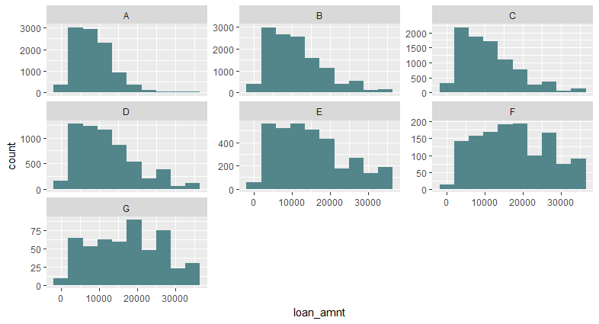

Answer the questions:

* 1. Which option did you choose to produce the above plot?
  2. Which credit grades have a mode below 10000?
  3. Which credit grades show a fairly uniform distribution?
  4. Are any of the distributions normal distributions?

**Outcome:** Code, Plot and Answers:

**Answers:**

* + - * 1. scale=”free_y”
        2. A, B, C have maximum loan amounts of below 10000. (A, B, C, D is also an acceptable answer)
        3. F and G show uniform distributions
        4. No, none of these distributions are normally distributed.

**Instructor Note:**

Students should figure out what needs to be changed in facet_wrap to produce the final plot.

**Topic C: Using and changing style and colors**

**Time: 1hr**

**Subtopic: using colors in plots**

Instead of faceting, we could also produce a color differentiated plot. It may be advantageous to use a color differentiated plot where the shapes are very similar and there is some overlap. To see small differences, it would be useful to use colors. For example, we can plot the Electricity consumption vs GDP but use different colors or shapes for the countries.

**Exercise:** Use color to group points by a variable

**Aim:** To produce a color differentiated scatter plot with respect to a third variable.

**Steps for completion:**

1. Choose a subset of data set 1 (gapminder) and select a few countries. Use subset command as below:

dfs <- subset(df,Country %in% c("Germany","India","China","United States"))

1. Make a scatter plot of the two variables and change the X and Y titles.

p1<- ggplot(df,aes_string(x=var1,y=var2))+

geom_point(color=2,shape=2)+xlim(0,10000)+xlab(name1)+ylab(name2)

1. Then change the color and shape of the points – Plot 1

p2 <- ggplot(df,aes_string(x=var1,y=var2))+ geom_point(aes(color=Country,shape=Country))+xlim(0,10000)+xlab(name1)+ylab(name2)

1. Now group points by “Country” mapped by color and shape – Plot 3 and Plot 4

grid.arrange(p1, p2, nrow = 2)

Go to https://goo.gl/RheL2G to access the code.

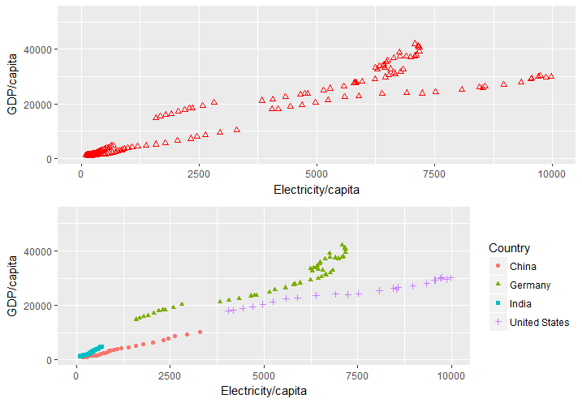

**Discussion:**

Question:

We see that as GDP/capita increases the electricity/capita consumption increases for all countries. Hence, what can we conclude about the correlation between the two quantities?

Answer:

Electricity consumption per capita is positively correlated with GDP per capita.

**Activity C:** Using color differentiation in plots

**Scenario:** A loan company has given loan amounts to people with different features, for example, employment status, home ownership, credit grade, etc. You want to see the relationship of some of those variables.

**Aim:** To view the distribution of loan amount vs home ownership color differentiated by Credit grade.

**Steps for Completion:**

1. Use the dataset: “LoanStats” and make a subset using the following variables as below:

dfn <- df3[,c("home_ownership","loan_amnt","grade")]

1. Clean the dataset (we want to remove the “NONE” and “NA” cases)

dfn <- na.omit(dfn)

dfn <- subset (dfn, !dfn$home_ownership %in% c("NONE"))

1. Create a box plot showing loan amount vs. homeownership (See code)
2. Answer the following questions:
   1. Which Credit grades have taken highest median loan amount? Which credit grades correspond to lowest loan amount.
   2. For credit grade F, are the loan amounts higher or lower if the person has a mortgage vs. the person who rents a home?
   3. By approximately how much does the median loan amount differ between credit grades A and G, for people who own a mortgage?

(Note: You have to do a finer labelling to answer this question)

**Outcome:**

Code, Plot and answers to Q4.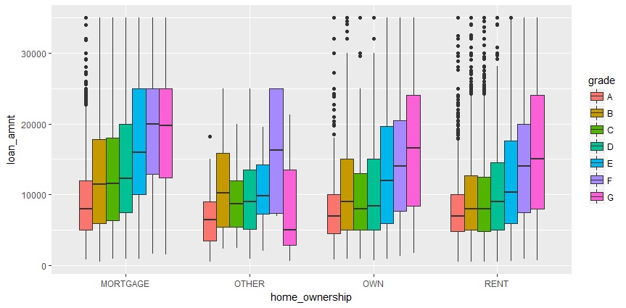

Answers:

1. A
2. Its higher for the person who has a mortgage
3. By about ~15000

**Subtopic: Themes and changing the appearance of graphs**

The grammar of graphics that underlies ggplot2 is concerned with how data is processed and displayed—it’s not concerned with things like fonts, background colors, and so on. To tune the appearance of these things, ggplot2’s theming system provides control over the appearance of such non-data elements. We will be touching upon a few thematic aspects in this course. It would not be possible to go over all thematic options. For a more complete list of options use the help guide, by typing ?theme or look at the ggplot2 manual.

Themes can be changed in multiple ways:

* Change it individually for each plot
* Use a pre-defined Theme
* Define your own theme and use it for all your plots.

**Caution**: The exercise below is intended to introduce you to different themes elements. The plot we produce at the end is not necessarily the best visual choice but is just to illustrate the options.

**Exercise:**

Using theme to customize a plot

**Aim:**

To use thematic commands to customize and improve a plot appearance.

**Steps for Completion:**

1. Let’s use the “HollywoodMovies” data and do a bar chart of movie titles and world Gross amount. Since we have too many we make a subset:

dfn <- subset (HollywoodMovies, Genre %in% c("Action","Adventure","Comedy","Drama","Romance")

& LeadStudio %in% c("Fox","Sony","Columbia","Paramount","Disney"))

1. Let’s pre-define a theme. Type ?theme (Alternatively while you type “theme” R shows you the options available - See snapshots below)
2. Some of the options available.

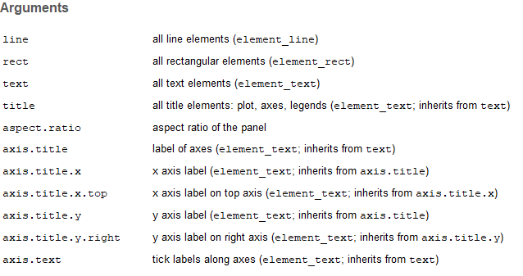

1. Note that axis.title is of type “element_text”, which in turn inherits from “text”
2. Hence, we will change aspects of element_text. Type ? element_text to bring up the options.

Use the table below to change some of the thematic aspects:

|  |  |  |
| --- | --- | --- |
| Argument | Type | Values |
| axis.title.x | Element_text | size=15, family=”Helvetica”, angle=45 |
| axis.title.y | Element_text | size=15, family=”Helvetica”, angle=45 |
| Panel.grid.major | Element_line | color=”gray87” |
| Panel.background | Element_rect | Fill=“Beige” |
| plot.background | Element_rect | Fill=”Gray”,size=20 |

R will automatically autofill and display options before you finish typing:

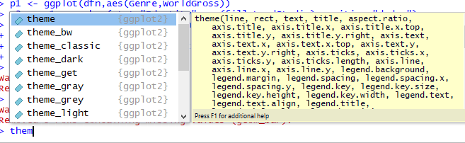

Setting the axis.title options brings up these options for element_text

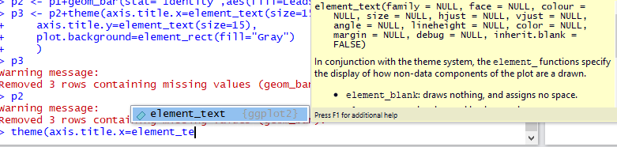

6. After studying the above options define a theme to produce the plot below (See code)

Outcome:

Go to https://goo.gl/RheL2G to access the code.

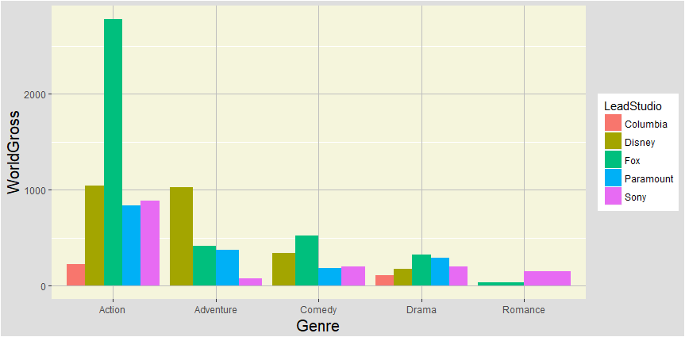

**Analysis:**

The above plot shows the “World Grossed amount” for the “different Genres” colored by the different production houses. One can see that the genre “Action” has the maximum earnings, and most of them are produced by “Fox”. “Disney” also earns more than other houses. Disney earns more than “Fox” for the “Adventure” genre.

**Discussion:**

What are some of the good and bad features about the above plot?

Answer:

**Good:** The X and Y titles are visible. The plot is color differentiated, making it easy to distinguish between the different studios. The grid lines are visible allowing us to read the values.

**Bad:** This plot has too many bright colors which is distracting. Panel background is better visualized as white. The labels are not very visible and would be nicer to have bigger font sizes.

But now you have the tools to customize and improve the plot.

**Instructor Note:**

Color palette can be found here : <http://www.stat.columbia.edu/~tzheng/files/Rcolor.pdf>

* **Using a predefined Theme**: There are some predefined themes that one can use. The same plots produced by using different themes are as below:

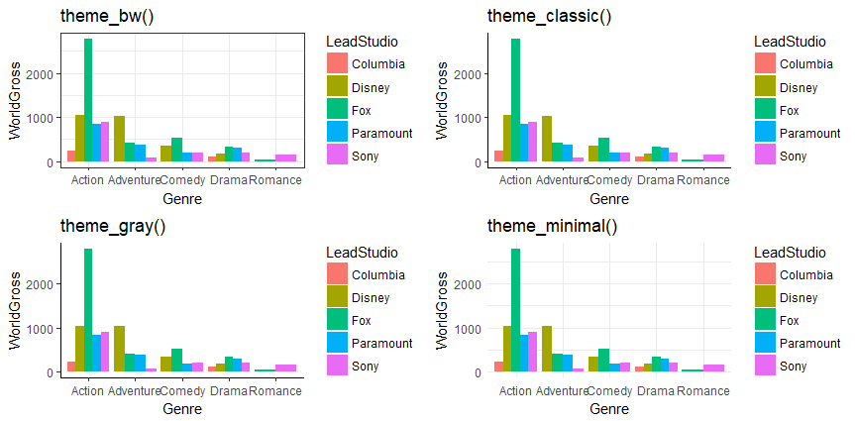

**Exercise:** Using or setting your own theme globally

**Aim:** To set your own theme for an individual plot or set it globally

**Steps for completion:**

1. Setup your theme:
   1. Change the legend title, and position
   2. Change the axes title colors, and relative size (1.5). Using “text” changes the colors of the axes titles and legend text, but not the label text.
   3. Change the axes label text sizes: Use “axis.text”. (Note: If you want to change the x and y axes separately use, axis.text.x and axis.text.y)

mytheme <- theme(text = element_text(color="Blue"), axis.text = element_text(size=12),axis.title = element_text(size = rel(1.5)))

1. Use your theme with an individual plot: p2 <- p1+mytheme (Click on “zoom” plot if it’s not clear or compressed in the canvas)
2. Or you can set it globally for all plots at the beginning of your code:

theme_set(mytheme)

**Outcome:**

Code and plot with mytheme

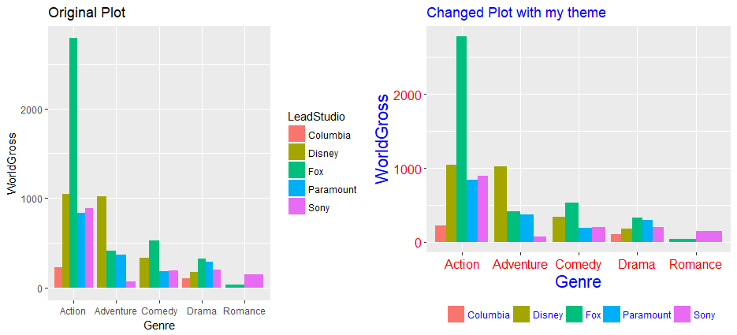

**Discussion:**

Can youlist some of the differences between the original and changed plot? Explicitly state which variable it is and how it changed.

**Answer:**

* 1. axis labels are changed from black to red
  2. The legend in the new plot is at the bottom and does not have a title
  3. The x-axis and y-axis titles are in Blue instead of black
  4. The plot title and the title color are changed.

**Instructor Note:**

Refer to the complete code which has been placed at: Code/Beginning-Data-Visualization-with-ggplot2-and-R/Lesson 2-Grammar of Graphics and Visual Components/(Exercise: Using or setting your own theme globally)

Go to https://goo.gl/RheL2G to access the code.

The default colors aren’t the most appealing, so sometimes you may want to use a different palette, by using scale_colour_brewer (), scale_fill_brewer, or scale_colour_manual ():

**Exercise:** Change the color scheme of the given theme

**Aim:** To change the color scheme and use a different palette.

**Steps for Completion:**

e

* + 1. Use the predefined theme, “theme_bw” and make the same plot as done previously:

p2+theme_bw()+ggtitle("theme_bw()")

* + 1. Now, we will use a different color palette.
    2. ?scale_fill_brewer gives the following palettes (Code snippet below):

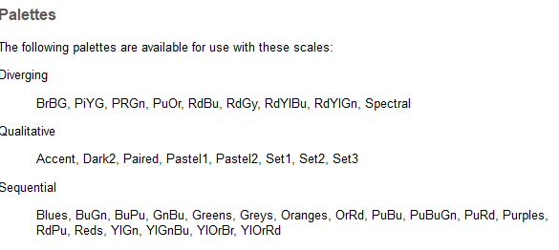

* + 1. Try using “Spectral”, “Pastel1” and “Oranges” and produce the plots below:

p4 + scale_fill_brewer(palette="Spectral")

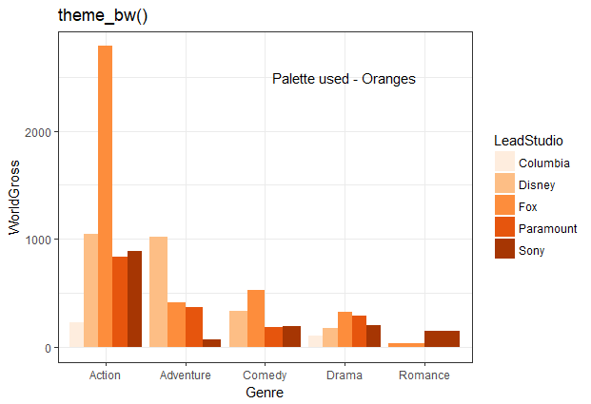

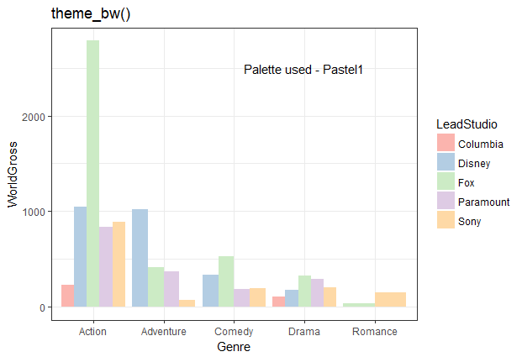

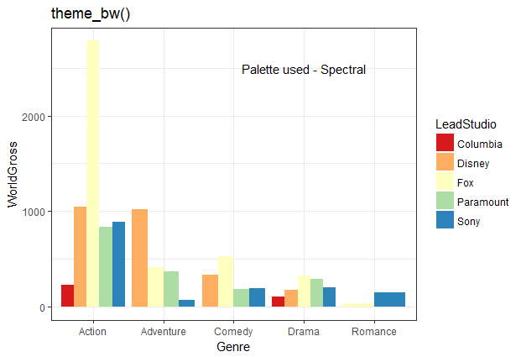

**Activity D:** Use themes and color differentiation in a plot.

**Aim:**

To plot the BMI’s of male vs. female for the different countries and analyze the plot.

**Scenario:**

Comparing two variables and differentiating by color may arise in cases, for example, a digital marketing company, wishes to compare the number of views of its ad in different websites, or it wishes to compare the number of clicks vs. number of views for different states for the same website.

**Steps for completion:**

1. Make a scatter plot of BMI of females’ vs males
2. You will be saving 3 plots as you build your plot in layers.
   1. The default plot. Store plot as p1.
   2. Points differentiated by color. Differentiate the two BMI’s by Country using color. Size of points = 2.
   3. Change the color scheme by using scale_color_brewer. The palette used is “Dark2”. Store plot as p2
   4. Add a plot title – “BMI female vs BMI Male”
   5. Change some more theme aspects to produce the plot p3. The theme aspects to be changed and their values are as below:
      1. Panel background – azure, color=black
      2. No grid lines
      3. Axis title size -15, Axis title color=cadetblue4
      4. Change x and y titles – “BMI female vs. BMI Male”
      5. Legend - Position bottom, Left justified, No Legend Title, legend key (fill – gray97, color of the line=3)
      6. Plot title – color (cadetblue4); size=18; face=”bold.italic”

**Outcome:**

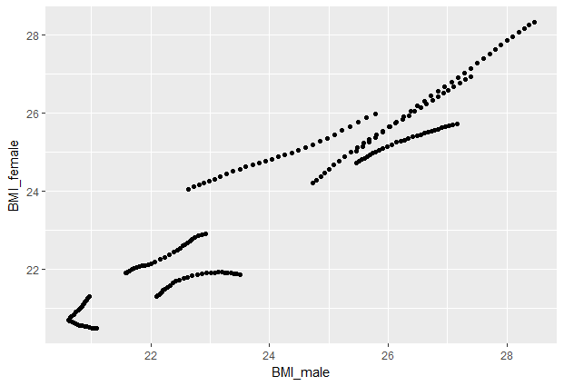

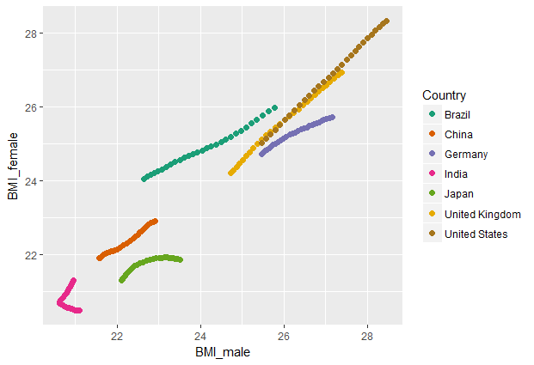

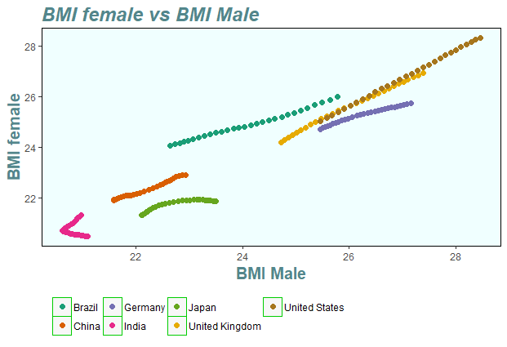

**Discussion:**

These are BMI values for different years.What is the correlation between BMI of male vs female for the different years? Is it the same for each country?

Answer:

The male and female BMIs are positively correlated in most cases, except in the case of India,

where both positive and negative correlation is seen.

**Instructor Note:**

Plots to be shown after completion of student activity. Please give hints if needed.

**Topic D: Geoms and Statistcal Summaries**

Sometimes, we need to calculate statistical summaries such as mean, median or some quartile of a variable and view its change with resepect to another variable. This can be done using “grouping” commands.

Let’s plot the Genre vs. “AudienceScore” for “HollywoodMovies” dataset. Change the angle of the axis labelling text to make it less cluttered.

ggplot(HollywoodMovies,aes(Genre,AudienceScore))+geom_point()+theme(axis.text.x=element_text(angle=40))

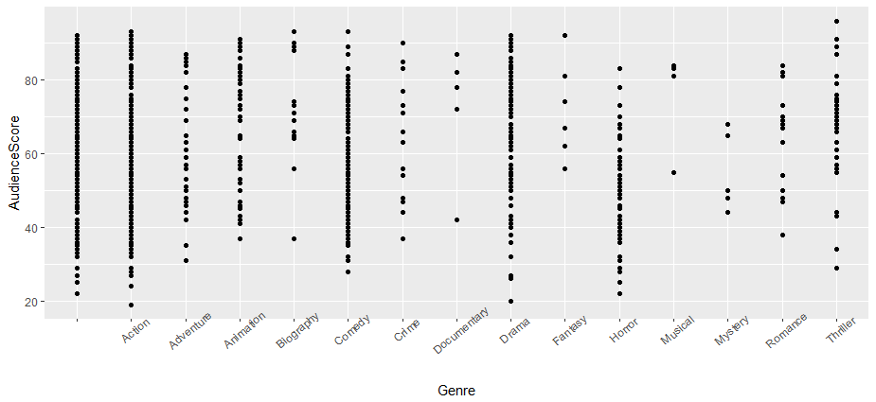

**Discussion:**

Question:

What would be a good way to compare the AudienceScores for the different Genres? Do we see a single value or multiple values for each Genre?

Answer:

We see that there are multiple values per Genre. One good way to compare the “AudienceScores” for the different Genres is to compare averages for each Genre. This is where we can use grouping. Let’s do an exercise.

**Exercise:** Using grouping to create a summarized plot

**Aim:** To use grouping to summarize multiple y-values for a given x-value

**Steps for completion:**

1. Use grouping to group by Genre and remove NULL values

gp_scr <- group_by(HollywoodMovies,Genre)

gp_scr <- na.omit(gp_scr)

1. Calculare mean and standard deviation using the function “summarise” and make a new dataset

dfnew <- dplyr::summarise(gp_scr,as_mean=mean(AudienceScore),

as_sd=sd(AudienceScore),n=n())

1. We want to make a plot where it scores are ordered by the means. Follow the steps in the code to do that. Plot the means.

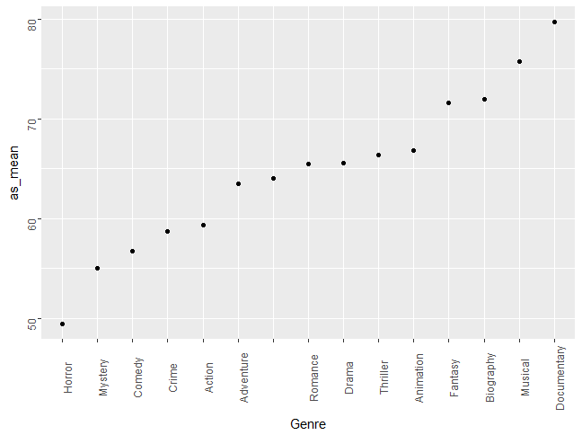

1. Make the final plot adding in error bars.

ggplot(data = dfnew, aes(x=Genre,y=as_mean))+

geom_errorbar(color="red",aes(ymin=as_mean-(as_sd/sqrt(n-1)), ymax = as_mean+(as_sd/sqrt(n-1))))+ylab("Audiencescore Mean")+theme(axis.text = element_text(angle=90))

Go to https://goo.gl/RheL2G to access the code.

Outcome: Code and Plot

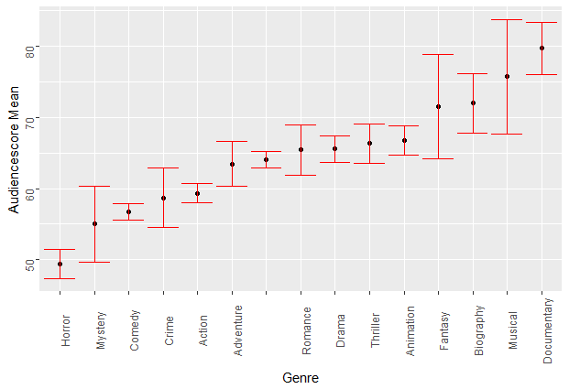

**Discussion:**

Question:

What are some observations about this graph?

Answer:

The Genre “Documentary” has received the highest average score of about 80, while the lowerst AudienceScore on an average is “Horror”. There is one Genre which is not categorized.. Comedy and action have lot of data (low error bars). Fantasy doesn’t have a lot of data, which may point to it being not that popular.

**Instructor Note:**

Initiate discussion asking students to comment on the graph. There could be other observations. This is intended to be open-ended. Some sample answers are provided.

**Logistics:**

Mention the topics covered so far and the topics that they will be working on for Lesson 3. Referto outline. Only some of the thematic options have been explored in this lesson. Students shouldbe encouraged to practice more on their own on the thematic options to get better control on the options.We used a scatter plot in the last activity. Students could try using some other geometricobject, like a boxplot, and exploring changes in themes in those plots.

**Summary:**

In this Lesson, we learn in greater details the Grammar of graphics and changing various theme

and color aspects of a graph so that the visual can be understood better and reveals greater details

about the data. We also learn how to get more useful information in scatter plots, through using

grouping and summarizing to get useful quantities like the mean, median, quartile etc. In the next

lesson, we shall work on some unconventional and more advanced plotting techniques which are

not commonly needed but may be required in some special cases.

**Practice Questions**

1. The command scale_x_continuous can be used to do which of the following:
   1. Change the variable from discrete to continuous
   2. Change the labelling from integer format to scientific format
   3. Set limits on the x axis.
   4. Both b&c
2. Faceting subdivides the data and produces multiplots. facet_grid could be used to produce some subplots arranged in M columns and N rows.
   1. True
   2. False
3. What would the command axis.title = element_blank() do?
4. For the command “group_by(Country, Gender)” which of these statements is/are true?
   1. Group by country using the Gender dataset
   2. Group by Gender using the Country dataset
   3. Group_by can be used for discrete or continuous variables
   4. Group_by can be used for discrete, and categorical variables.

**Answers:**

* + 1. c
    2. b
    3. It would remove the titles for both x and y axis.
    4. b & d